**Project Objective:**

Creation of a web based chatbot application which would enable us to solve user queries around Covid-19. We aim to create more awareness among people by letting users directly interact with the chatbot which uses trusted sources to gather information.

Our web based platform would contain two core features :

1: A chatbot which is able to answer user based queries based around the COVID-19 Pandemic.

2: A map based feature which represents the world in a manner which is user interactable.

So,the feature would be implemented by following a weekly sprint plan with two major milestones.

**Project Plan :**

Milestone 1 (30th June 2020) : Chatbot having the ability to answer predefined user queries with the world map being functional at a basic level.

Milestone 2 (11th August 2020) : A higher implementation of the chatbot with the ability to interact with the user and answer a few customised user queries.World map would contain information regarding the statistics of Covid-19 for each country.

**Roles:**

**Aditya:**

**Primary role :** UI Design and Front End Developer.

**Secondary role**: Integration of Front End with the backend of the application.

**Apurva:**

**Primary Role:**Data Mining and Data Cleaning.

**Secondary Role**:NLP Processing for Text.

**Ashwin**:

**Primary Role**: Cloud Deployment and Integration.

**Secondary Role**: Data Mining and Data Cleaning.

**Sumit:**

**Primary Role:** Creation of Backend and Integration of the application.

**Secondary Role:** Cloud Deployment and Integration.

**Nripendra:**

**Primary Role:** NLP processing for Text.

**Secondary Role:**Creation of Backend and Integration of the application.

**Architecture** :

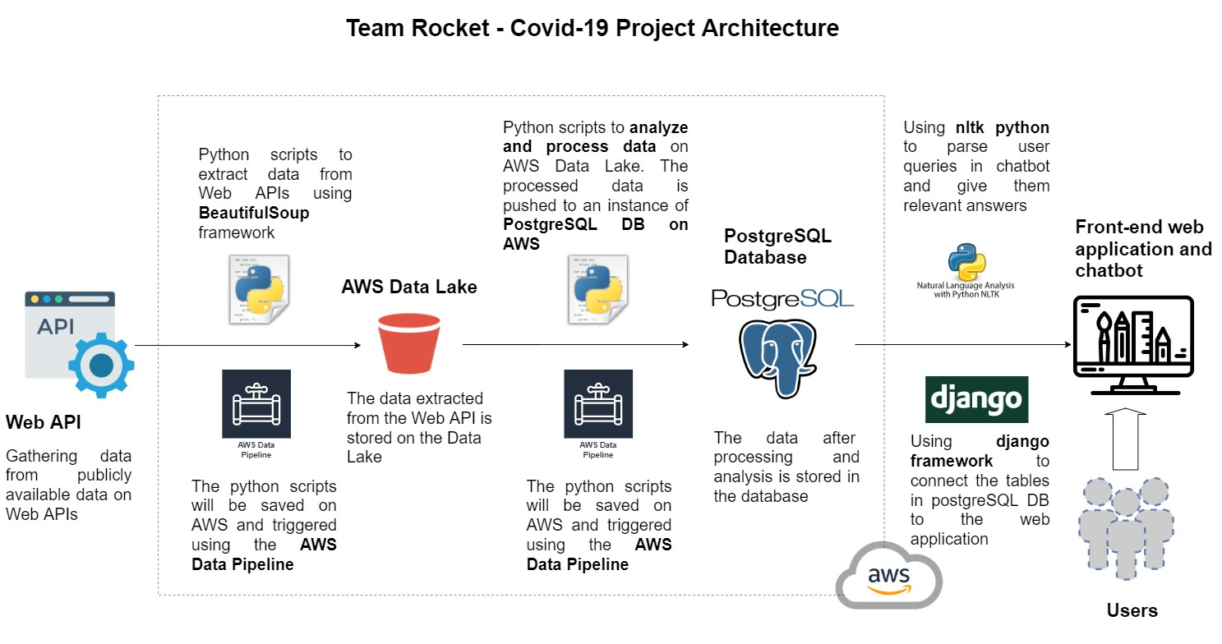

Sprint plan:

Git: